**Part 1**Load the data to rapid minder and join the tables  
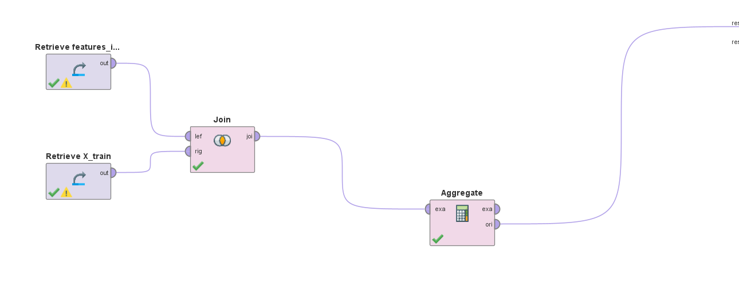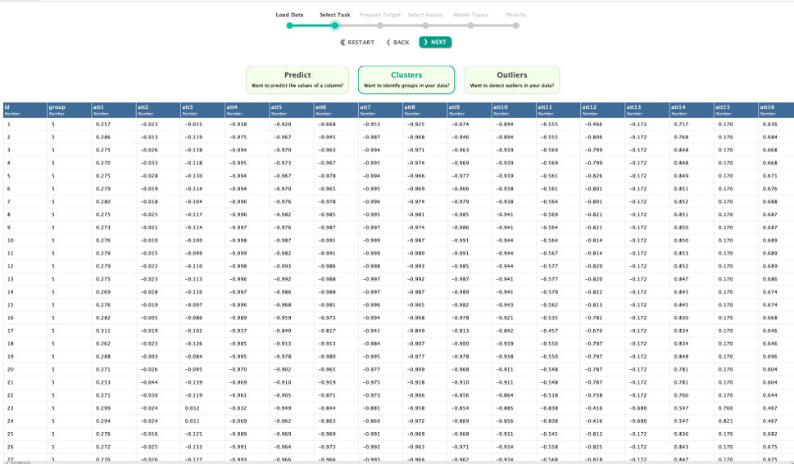Click clusters and next  
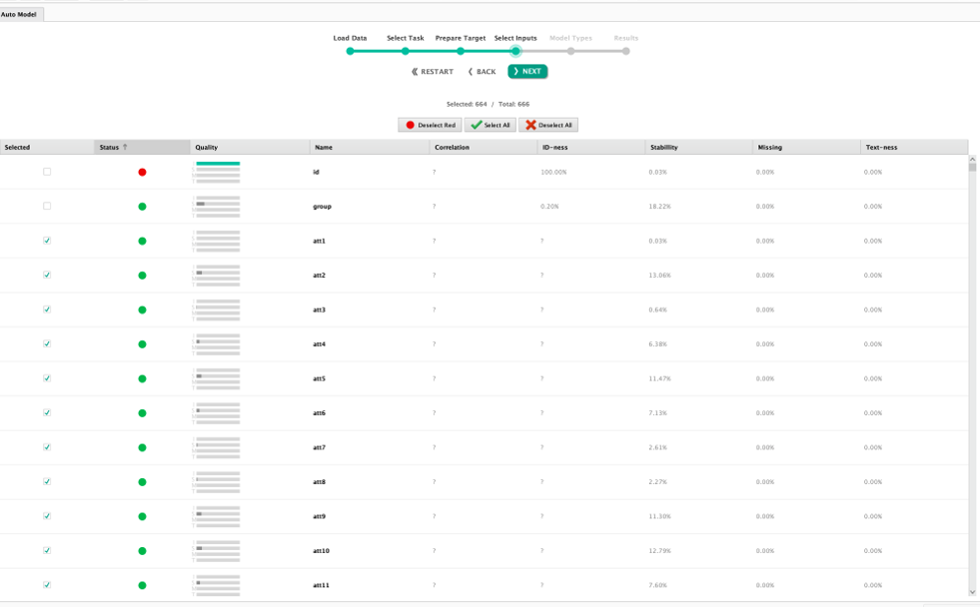

Select no of clusters with maximum cluster range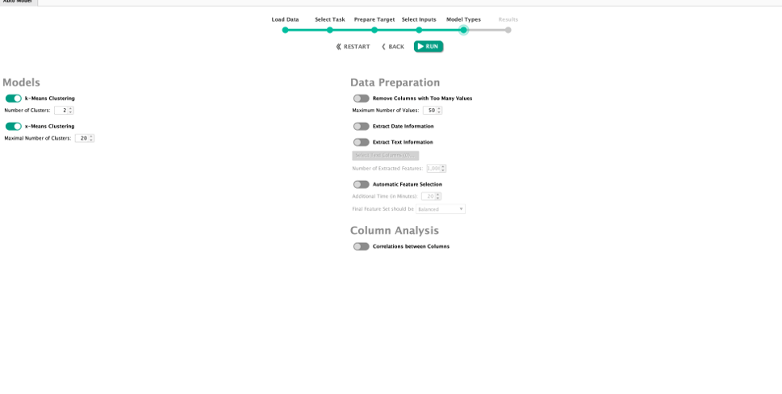changed to 6 as per the expert file  
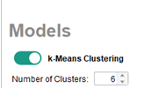

Cluster tree  
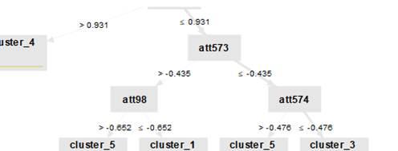

**How do you think the values used serve as the clustering points?**

The values used in clustering determine the similarity or dissimilarity between data points, typically based on their attributes or features. Here's how these values are utilized

Similarity Measure: Algorithms calculate similarity (e.g., Euclidean distance) between data points based on attribute values. More similar points are closer in feature space.

Centroid Calculation: In k-means, the centroid is the average of the attribute values of points in a cluster, representing the cluster's center.

Density-Based Clustering: In DBSCAN, points are clustered based on the density of points in a neighbourhood. Core points have a minimum number of neighbors within a certain distance.

Hierarchical Clustering: Similarity between clusters is based on the similarity of their data points, often calculated using linkage criteria (e.g., single, complete, average linkage).

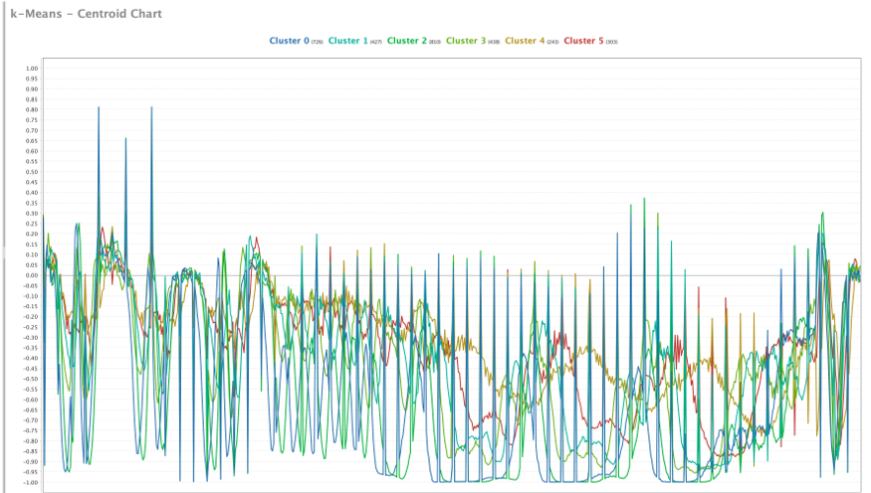

.

**What does this chart show us about the clusters?**

This k-Means Centroid Chart displays the average values of features for six clusters, identified by different colors. Each line represents the centroid of a cluster, showing the typical feature values for the data points in that cluster. By comparing these lines, we can see how the clusters differ in terms of their feature values. Peaks and valleys indicate the importance of certain features in each cluster, helping us understand the unique characteristics of each group.

**Explain why Cluster Analysis is a useful tool and how might it be used to classify groups of customers?**

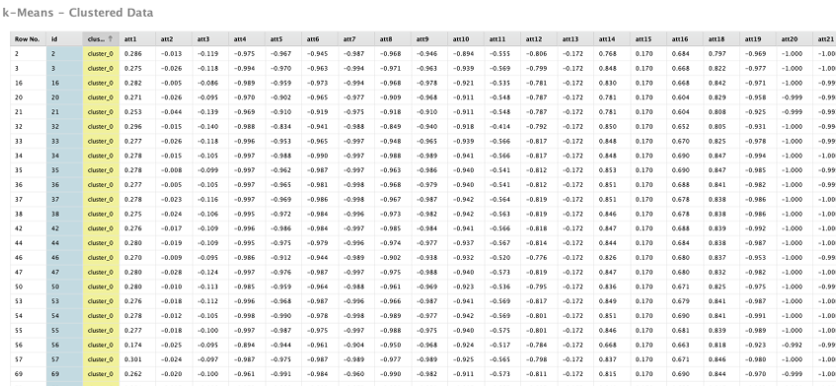

Cluster analysis is a valuable tool because it groups data points with similar characteristics, making it easier to identify patterns and trends within large datasets. This process simplifies complex data, making it more understandable and interpretable. It also aids in detecting anomalies, as clusters help highlight outliers that deviate from the norm. By revealing underlying structures and relationships, cluster analysis generates insights that may not be immediately obvious.

In the context of customer classification, cluster analysis can be used for market segmentation by grouping customers based on purchasing behavior, preferences, or demographics. This allows businesses to develop more targeted marketing strategies. Additionally, it enables personalized recommendations by identifying customers with similar behaviors or preferences. Creating detailed customer profiles through clustering helps improve customer service and engagement. Moreover, cluster analysis can predict customer churn by identifying groups of customers at risk of leaving, allowing businesses to take proactive retention measures.

**Part 2 – Use Rapid Miner to create an Artificial Neural Network (ANN) Model (aka Deep Learning) and Support Vector Machine (SVM) using the sample dataset provided by Rapid Miner**

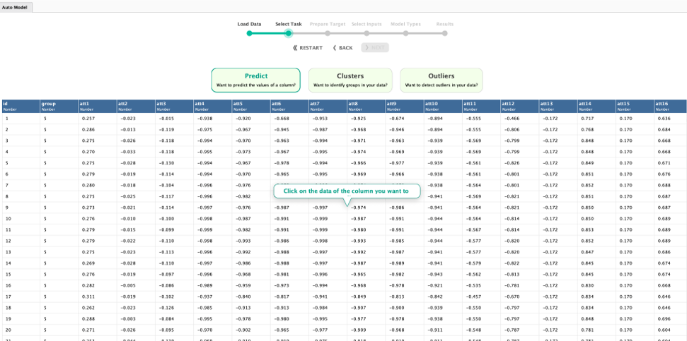

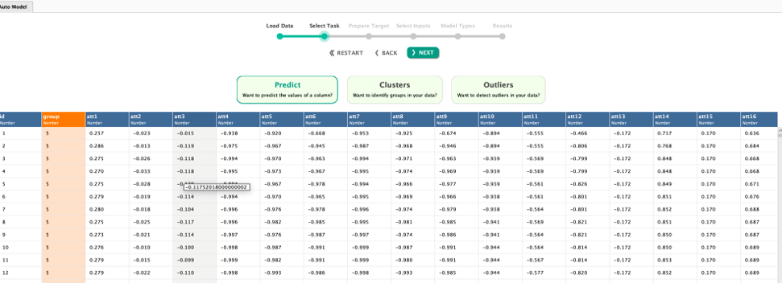  
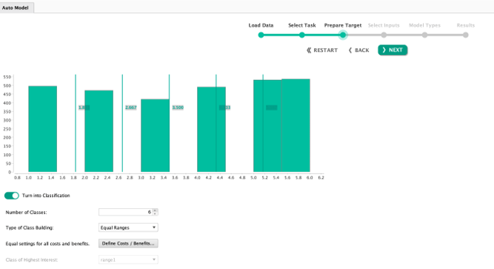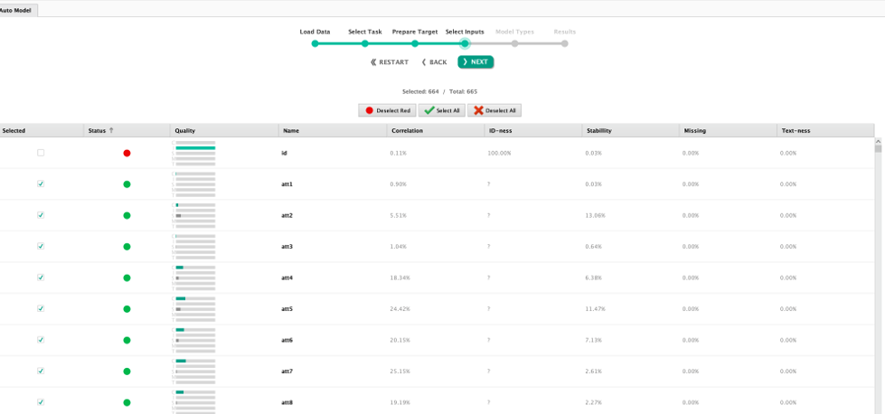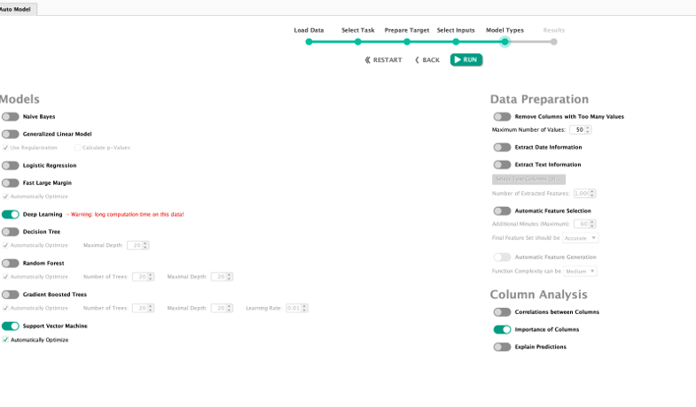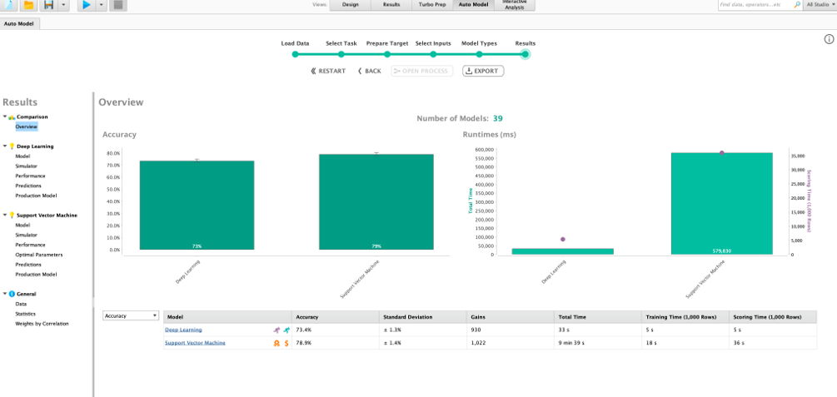  
**Which model has a lower Standard Deviation? Is a lower standard deviation a good condition? Why**

Deep learning shows a lower standard deviation in accuracy levels, which is generally positive. A lower standard deviation indicates that data points are closer to the mean, suggesting less variability. This consistency is beneficial in areas like manufacturing or financial investments, where stable and predictable outcomes are crucial. It also enhances predictability, making future outcomes easier to forecast, aiding in risk assessment and decision-making. Additionally, a lower standard deviation means the mean more accurately represents the dataset, leading to more reliable conclusions. In quality control, it signifies a stable process with consistent results, making it easier to identify and address anomalies.

**How does that relate to the Classification error?**

The relationship between standard deviation and classification error depends on the data and the classification model. Here are some ways they might relate:

1. **Data Distribution**: A lower standard deviation means data points are closer to the mean, which can make it easier for the model to distinguish between classes, potentially reducing classification error.
2. **Model Performance**: Features with lower standard deviation are more tightly clustered, which can lead to better model performance and less sensitivity to data variations, potentially lowering classification error.
3. **Feature Selection**: When selecting features, those with low standard deviation may be less informative for classification. Prioritizing features with higher standard deviation might improve classification performance and reduce error.
4. **Overfitting**: A low standard deviation in training data might indicate overfitting if the model captures noise rather than patterns, leading to higher classification error on new data. Balancing model complexity with data variability is essential to avoid overfitting and improve generalization performance.

**Which model has the higher accuracy?**

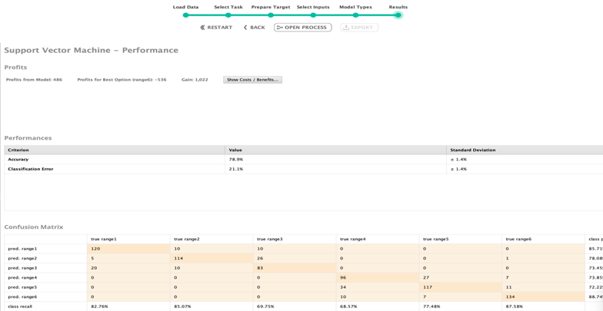

Support vector machines have a higher precision rate. A lift chart, or gain chart, is used in marketing and predictive modeling to evaluate the performance of classification or regression models. It visually represents how well a model distinguishes between classes or predicts a target variable. To create a lift chart, the dataset is split into training and testing subsets, the model is trained on the training data, and predictions are made on the testing data. Predicted outcomes are ranked or grouped into bins, such as deciles based on predicted probabilities. Cumulative metrics like the number of actual positive instances and the cumulative response rate are then calculated for each bin. The lift chart is plotted with the X-axis representing the percentage of data points sorted by predicted values (0% to 100%) and the Y-axis showing the cumulative response rate or number of positive instances. This helps assess the model's effectiveness in predicting the target variable.

**Finally, compare and contrast the three model types that we used in this lab (ANN, SVM and k-Means).**

ANN (Artificial Neural Network):

* 1. Functionality: ANNs are a type of machine learning model inspired by the biological neural networks of the human brain. They consist of interconnected nodes organized into layers, including input, hidden, and output layers.
  2. Application: ANNs are used for supervised learning tasks such as classification and regression. They are effective for complex problems with large amounts of data, such as image recognition, natural language processing, and time series prediction.
  3. Training: ANNs require extensive training with large datasets to adjust the weights and biases of connections between nodes. Training is typically done using optimization algorithms like gradient descent.
  4. Flexibility: ANNs can learn complex nonlinear relationships in data but may suffer from overfitting if not properly regularized. They offer high flexibility but require careful tuning of hyperparameters.

SVM (Support Vector Machine):

* 1. Functionality: SVMs are supervised learning models used for classification and regression tasks. They work by finding the hyperplane that best separates data points belonging to different classes in a high-dimensional feature space.
  2. Application: SVMs are effective for binary classification tasks and can be extended to handle multi-class classification and regression problems. They are widely used in fields such as image classification, text classification, and bioinformatics.
  3. Training: SVMs require training with labeled data to find the optimal hyperplane that maximizes the margin between classes. They use techniques like kernel trick to handle nonlinear separable data.
  4. Interpretability: SVMs provide clear decision boundaries and are relatively easy to interpret compared to some other models. They are robust to overfitting, especially in high-dimensional spaces.

k-means Clustering:

* 1. Functionality: k-means is an unsupervised learning algorithm used for clustering tasks. It partitions data points into k clusters based on their similarity, where k is a user-defined parameter.
  2. Application: k-means is used for clustering data into groups based on similarity. It is commonly applied in customer segmentation, image compression, and anomaly detection.
  3. Training: k-means iteratively assigns data points to the nearest cluster centroid and updates the centroids based on the mean of the data points assigned to each cluster. The algorithm converges when centroids no longer change significantly.
  4. Scalability: k-means is computationally efficient and scales well to large datasets. However, it may struggle with non-linear or non-spherical clusters and is sensitive to the initial choice of centroids.

In summary, ANNs, SVMs, and k-means clustering are all machine learning techniques used for different types of tasks (supervised learning, unsupervised learning, and clustering, respectively) and have their own strengths and weaknesses in terms of applicability, interpretability, training requirements, and scalability.

**Part 3 :** Successfully exit from rapid minder